Assignment: Network Devices

1. Home Network Diagram
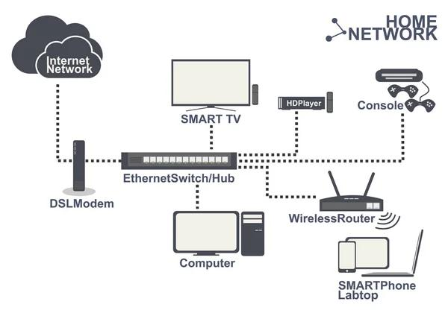
Router connects the home to the Internet. Switch connects multiple wired devices. Smartphone connects through Wi‑Fi, while the laptop and Smart TV connect through Ethernet.
Insert the home network image from the chat here.

2. Comparison of Network Devices
Device | Function | Real-world Use Case
Router | Connects networks and provides Internet access | Home Wi‑Fi for YouTube streaming
Switch | Connects wired devices in a LAN | Computer lab or LAN gaming
Hub | Broadcasts data to all ports | Older small office networks
Access Point | Provides wireless connectivity | College or café Wi‑Fi

3. Zomato Scenario
When a food order is placed on Zomato, the smartphone sends data to the access point in the Wi‑Fi router. The router forwards the request to the ISP and then to Zomato's servers. If wired devices are present, a switch forwards LAN traffic. The server response returns through the router and access point back to the smartphone.

4. Connecting a Gaming PC
Option 1: Wi‑Fi Range Extender with an Ethernet port. The extender receives the router's Wi‑Fi signal and the PC connects to it using Ethernet.
Option 2: Powerline Adapter. One adapter connects to the router and another to the PC through the home's electrical wiring, providing a stable wired connection. Powerline adapters are generally preferred for gaming due to lower latency.

